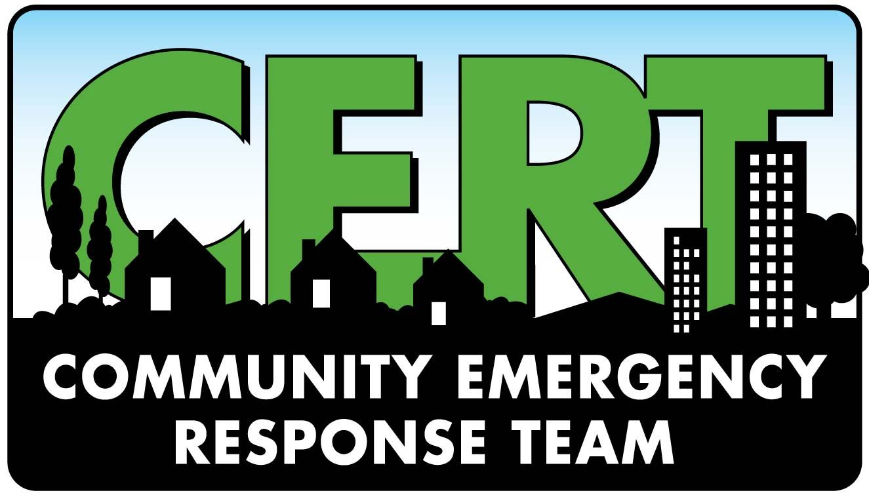

The Town of Little Compton EMA is in the process of establishing a Community Emergency Response Team (CERT). What does a CERT do?
The Community Emergency Response Team (CERT) program educates volunteers about disaster preparedness for the hazards that may affect their area and trains them in basic disaster response skills, such as fire safety, light search and rescue, team organization, and disaster medical operations.
All training for the CERT will be provided by the town at no cost to the volunteer. All training classes will be conducted at the Public Safety Complex. Classes will be held on two nights per week for approximately eight weeks.
If you are interested in joining the CERT, please email Chief Petrin at rpetrin@tlcri.com

